

**ONLINE SHOPPING PLATFORM FOR STUDENTS, TEACHERS AT FPTU**

**Software Requirement Specification**

– HoChiMinh, September 2022 –

**Table of Contents**

I. Overview 3

1. Introduction 3

2. System Functions 4

3. Common Requirements 5

II. Functional Requirements 6

1. <<Feature Name 1>> 6

a. <<Function Name 1>> 6

b. <<Function Name 2>> 6

2. <<Feature Name 2>> 6

# I. Overview

## 1. Introduction

App "Online shopping platform for student, teachers at FPTU" was written to support the purchase and sale of all kinds of products by students and teachers at FPT University's Campuses via the internet.

"Online shopping platform for students, teachers at FPTU" is a new software system that replaces the current manual and telephone processes for buying and selling products. The system is expected to evolve over several releases, eventually connecting to the Internet buying and selling service for students and teachers of FPT University and being paid by e-wallets, products will be shipped by GHN.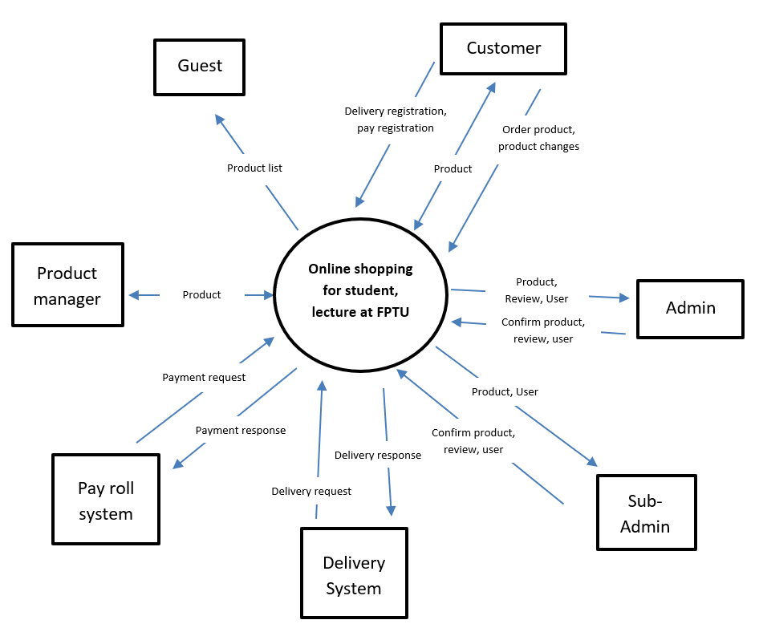

## 2. System Functions

#### a. Screen Flow

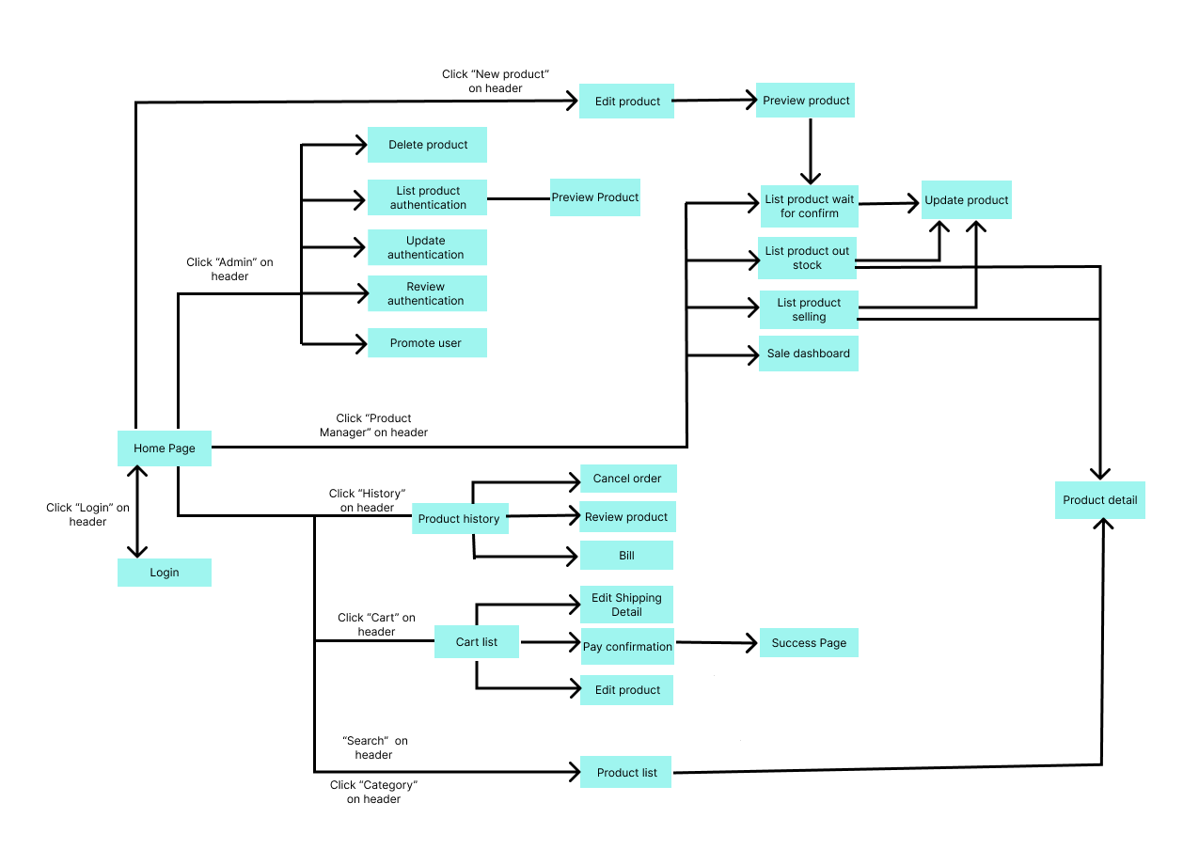

#### b. Screen Details

| **#** | **Feature** | **Screen** | **Description** |
| --- | --- | --- | --- |
| 1 | New Product | Create Product | Users insert new product information for sale on the app. |
| 2 | New Product | Preview Product | Users can change their product information. |
| 3 | Delete Product | Admin, Sub-Admin | Admin can delete products. |
| 4 | Product authentication | Admin, Sub-Admin | Admin approves the user's new product. |
| 5 | Update authentication | Admin, Sub-Admin | Admin approves user changes to product information. |
| 6 | Review authentication | Admin, Sub-Admin | Admin approve user reviews. |
| 7 | Promote, Demote user | Admin | Admins can promote users to admin or vice versa. |
| 8 | Login | Login | Login by email to buy products. |
| 9 | Search Product | Main | Search product. |
| 10 | Waiting for approves | Manager Product | Users can see their pending products. |
| 11 | Out stock Product | Manager Product | Users can see their sold out products. |
| 12 | Selling Product | Manager Product | Users can see the products they are selling. |
| 13 | DashBroad | Manager Product | Users can see the dashboard. |
| 14 | Update Product | Update Product | Users can update and delete their product. |
| 15 | History Product | History | Users can view their product purchase history. |
| 16 | Edit Cart | Cart | Users can add the products they want to buy to the cart. |
| 17 | Edit shipping | Shipping Information | Users can change and verify shipping information before order. |
| 18 | Order | Pay confirmation | Users can choose payment methods. |
| 19 | Admin dashboard | Admin, Sub-Admin | Statistics web. |
| 20 | Edit profile | User Information | Users can update their information. |
|  |  |  |  |

#### c. User Authorization

| **Screen** | **Guest** | **Customer** | **Sub-Admin** | **Admin** | **Bought Product** |
| --- | --- | --- | --- | --- | --- |
| <<Screen Login>> | x | x | x | x | x |
| Login Email FPT | x | x | x | x | x |
|  |  |  |  |  |  |
| <<Screen Main>> | x | x | x | x | x |
| Search Product | x | x | x | x | x |
| Query Category List | x | x | x | x | x |
| Query Best Seller Product | x | x | x | x | x |
| Query New Product | x | x | x | x | x |
| Product Page Information | x | x | x | x | x |
|  |  |  |  |  |  |
| <<Screen Product Information>> | x | x | x | x | x |
| View Seller Information | x | x | x | x | x |
| Buy Product |  | x | x | x | x |
| Add Product To Cart |  | x | x | x | x |
| Review Product |  | x | x | x | x |
|  |  |  |  |  |  |
| <<Screen Cart>> |  | x | x | x | x |
| List Items |  | x | x | x | x |
| Pay Confirmation |  | x | x | x | x |
| Delete Product |  | x | x | x | x |
| Adjust Product Quantity |  | x | x | x | x |
| Update Information For Shipping |  | x | x | x | x |
| Query Shipping Information |  | x | x | x | x |
|  |  |  |  |  |  |
| <<Screen Pay>> |  | x | x | x | x |
| Update Information For Shipping |  | x | x | x | x |
| Query Shipping Information |  | x | x | x | x |
| Insert Information Payment |  | x | x | x | x |
| Insert Information For Shipping |  | x | x | x | x |
| Payment |  | x | x | x | x |
|  |  |  |  |  |  |
| <<Screen Bill>> |  | x | x | x | x |
| Show Bill |  | x | x | x | x |
| Query Cancel Order |  | x | x | x | x |
| Query Confirm Cancel Order |  | x | x | x | x |
| Return HomePage |  | x | x | x | x |
|  |  |  |  |  |  |
| <<Screen Upload New Product>> |  | x | x | x | x |
| Upload Image |  | x | x | x | x |
| Upload Category |  | x | x | x | x |
| Upload Product Name |  | x | x | x | x |
| Upload Price |  | x | x | x | x |
| Insert Product Detail |  | x | x | x | x |
| Upload Seller Information |  | x | x | x | x |
| Send Request Product Authenticate |  | x | x | x | x |
| Preview Product Detail |  | x | x | x | x |
|  |  |  |  |  |  |
| <<Screen User Information>> |  | x | x | x | x |
| Insert User Information |  | x | x | x | x |
| Insert Update Information |  | x | x | x | x |
| Query User Information |  | x | x | x | x |
|  |  |  |  |  |  |
| <<Screen User Buy>> |  | x | x | x | x |
| Query All Ordered Product |  | x | x | x | x |
| Select Bill Detail |  | x | x | x | x |
|  |  |  |  |  |  |
| <<Screen Selling Product>> |  | x | x | x | x |
| Query All Selling Product |  | x | x | x | x |
| Query Out Stock |  | x | x | x | x |
| Pending Product Authentication |  | x | x | x | x |
| Dashboard |  | x | x | x | x |
| Delete Product Selling |  | x | x | x | x |
| Update Product Selling |  | x | x | x | x |
| Confirm Delete Product Selling |  | x | x | x | x |
|  |  |  |  |  |  |
| << Screen Out of Stock Product >> |  | x | x | x | x |
| Delete Product Selling |  | x | x | x | x |
| Update Product Selling |  | x | x | x | x |
| Confirm Delete Product Selling |  | x | x | x | x |
|  |  |  |  |  |  |
| <<Pending Product Authentication >> |  | x | x | x | x |
| Delete Product Selling |  | x | x | x | x |
| Update Product Selling |  | x | x | x | x |
| Confirm Delete Product Selling |  | x | x | x | x |
|  |  |  |  |  |  |
| <<Screen Review Product>> |  |  |  |  |  |
| Insert Review Product |  |  |  |  |  |
|  |  |  |  |  |  |
| <<Screen Admin>> |  |  |  | x |  |
| Search User |  |  |  | x |  |
| Query User List |  |  |  | x |  |
| Demote Sub Admin |  |  |  | x |  |
| Promote User to Sub Admin |  |  |  | x |  |
| Confirm New Product |  |  |  | x |  |
| Confirm Review |  |  |  | x |  |
| Confirm Update Product Information |  |  |  | x |  |
| Query All Product |  |  |  | x |  |
| Delete Product |  |  |  | x |  |
| Confirm Delete Product |  |  |  | x |  |
|  |  |  |  |  |  |
| <<Screen Sub Admin>> |  |  | x | x |  |
| Confirm New Product |  |  | x | x |  |
| Confirm Review |  |  | x | x |  |
| Confirm Update Product Information |  |  | x | x |  |
| Query All Product |  |  | x | x |  |
| Delete Product |  |  | x | x |  |
| Confirm Delete Product |  |  | x | x |  |
|  |  |  |  |  |  |

#### d. Non-Screen Functions

*[Provide the descriptions for the non-screen system functions, i.e batch/cron job, service, API, etc.]*

| **#** | **Feature** | **System Function** | **Description** |
| --- | --- | --- | --- |
| 1 | New Product | createProduct | Insert new product information into database. |
| 2 | Add Cart | addCart | Insert or update products in the cart into the database. |
| 3 | Delete Product | deleteProduct | Delete product in database. |
| 4 | Product authentication | updateProduct | Update product in database. |
| 5 | Updata authentication | checkProduct | Update status product in database. |
| 6 | Review authentication | checkReview | Update user reviews to database. |
| 7 | Promote, Demote user | updateRole | Update role of user in database. |
| 8 | Update Product | update Product | Update information of products in database. |
| 9 | Edit Cart | updateCart | Update information of product in cart into database |
| 10 | Edit shipping | updateShipping | Update shipping Information in database |
| 11 | Order | pay confirmation | Insert payment method into database |
| 12 | Admin dashboard | dataAdminDB | Statistics web. |
| 13 | Edit profile | updateProfile | Update information of user in database |
| 14 | Pay | payment | Send information to sandbox environment |

## 

## 

## 

## 3. Common Requirements

* Create an online store for FPTU students, teachers and staff.
* Users can upload a new product for sale.
* Main page should have top seller products and new products.
* Admin must approve products for sale.
* Admin must approve reviews for the product.
* Admin can promote and demote user roles.
* Seller should have a page for controlling the product.
* Users can check order history.
* Users can update their information.
* Sellers should be able to preview their product before submitting.
* Users should be able to cancel their order.
* Users should be able to update their product information.
* Users must login by FPT email.

# II. Functional Requirements

## 1. <<Feature Name 1>>

### a. <<Function Name 1>>

*[A function can be a screen or a non-screen function (listed in the part 5.1 above). In this part, you need to provide the details on the related function, focus on mentioning below information*

* *Function trigger: how this function is triggered (navigation path, a timing frequency, etc.*
* *Function description: actors/roles, purpose, interface, data processing, etc.*
* *Screen layout: mockup prototype of the screen, sample below is for Manage Products screen*

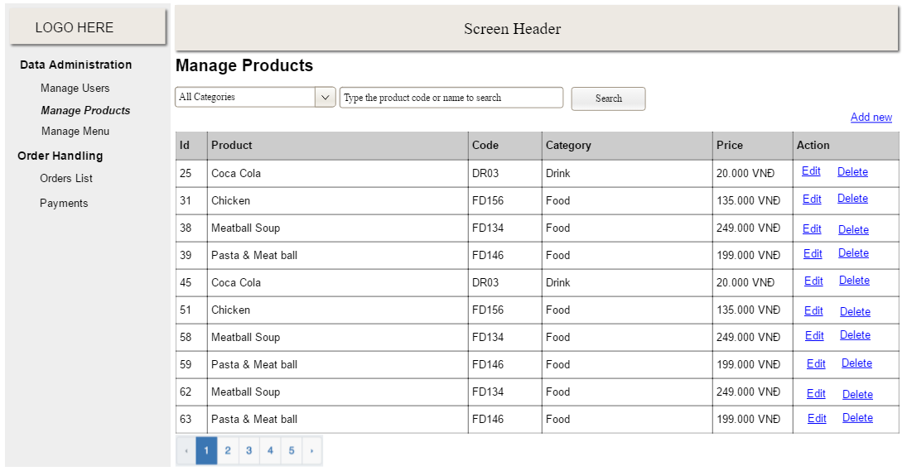

* *Function Details: provide explanation for the data, validation, business logics, functionalities (for both normal cases and abnormal cases), etc. of the function so that the reader can image how it work.*

*]*

### b. <<Function Name 2>>

…

## 2. <<Feature Name 2>>

…